**Course: Advance Bio Informatics**

**Module Title: Downloading Server**

**Module No: 86**

**Downloading Server**

In order to store data into databank, data must be downloaded first from data sources. Data is in many formats images, web pages, dbs, clinical data etc. Different locations for data download. Dbs allow access to download data through FTP servers.

Databases expose data in many release versions. Data is huge in volume, often in GB’s and TB’s. Data can be downloaded manually or through computer program. Manual downloading can be quite cumbersome. Often, different computer programs are written to download data automatically. These computer programs can be made configurable i.e. they can start automatically at some configurable time, download data and shut down automatically.

As data is huge in volume and its downloading can be resource insensitive & time consuming, usually a dedicated downloading server is used for this purpose. Output of downloading Server is input to the Processing Engine.

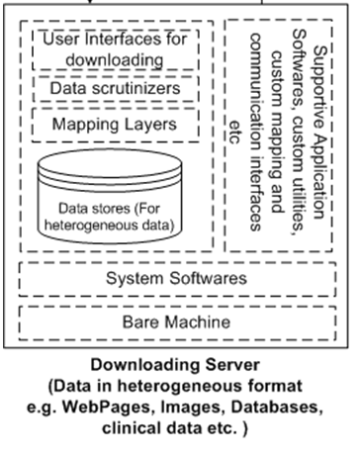

**User interfaces** for downloading – GUIs for users to download biological data

**Data Scrutinizers** – Examining, Filtering, trimming and sorting of biological data

**Mapping Layers** – Use to map the biological data, according to the standards of underlined data store.

**Data Store** – Use to store heterogeneous data

**Supportive application software** – MS office, Editors, Browsers, DBMS, XML Parsers etc

**Custom Utilities** – e.g. Scrutinizers, Data readers and writers, parsers etc.

Custom **mapping and communication** interfaces – For enabling interaction among components

**System software** – All necessary softwares for hardware management

**Bare machine** – All types of attached hardware